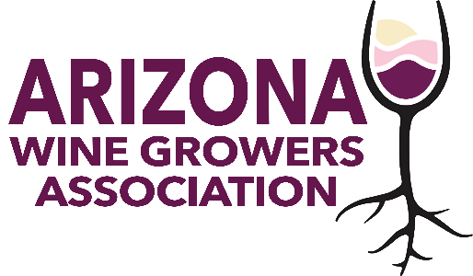
AWGA BOARD MEETING
June 12, 2024
4 – 5 p.m.
Via Zoom

AGENDA

Welcome

Copper State Wine Festival
Emily Rieve

Sonoita Wine Festival Update
Kent Callaghan

AZ Water Policy Position
Greg Gonnerman

Other Business

Adjourn

Next AWGA Board Meeting
July 10, 2024
4 p.m. (AZ time)

