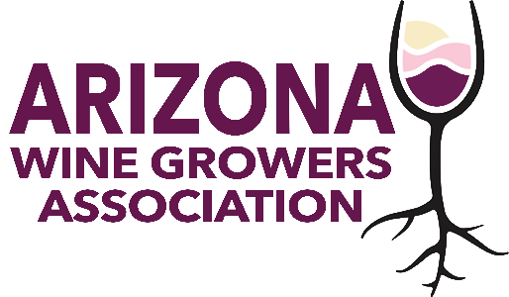
AWGA BOARD MEETING
May 15, 2024
4 – 5 p.m.
Via Zoom

AGENDA

Welcome

Treasurers Report
Jessica Hitchcock

Sonoita Wine Festival
Kent Callaghan

AZ Water Policy Position Statement Roll Out
Greg Gonnerman / Jennifer Montgomery

Crush Report Powerpoint Presentation
Matt Halldorsen

WineAmerica Update
Kelly Bostock

Special Election / Southern Representative
Jennifer Montgomery

Staffing Update
Jennifer Montgomery

Other Business

Adjourn

Next AWGA Board Meeting
June 12, 2024
4 p.m. (AZ time)

