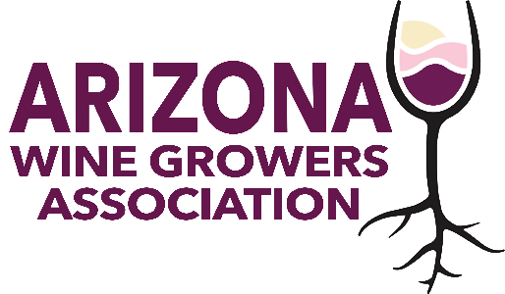
AWGA BOARD MEETING
April 10, 2024
4 – 5 p.m.
Via Zoom

AGENDA

Welcome

Treasurers Report
Jessica Hitchcock

Sonoita Wine Festival
Kent Callaghan

AZ Water Policy Position Statement
Kent Callaghan / Greg Gonnerman

S+C Communications Taglines
Jennifer Montgomery

Website Walkthrough
Jennifer Montgomery

EDA Recompete Letter of Support
Kelly Bostock

Other Business

Adjourn

Next AWGA Board Meeting
May 8, 2024
4 p.m. (AZ time)

